Abstract

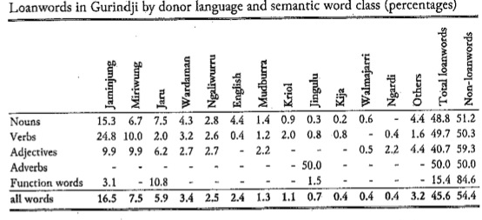
Language contact has featured prominently in historical analyses of Australian languages. Australian languages are also seen in the wider literature (e.g. Haspelmath 2004) to represent a case of high borrowing; this is confirmed with Gurindji, the sole example of an Australian language in Haspelmath and Tadmor's (2009) typology of loanwords. The real picture for Australia, however, reveals that Gurindji is quite atypical, and despite contact, the number of loan items in basic vocabulary for most languages is small. The data reveal considerable variation in loans, even among languages which had extensive contact with their neighbors. The results range from under 10% loans to almost 50%. This study therefore shows that loan rates in Australian languages (at least the ones surveyed here) are for the most part considerably lower than have been assumed, and do not irretrievably cloud Australian reconstructible linguistic history.

Background
§1 Language contact has featured prominently in historical analyses of Australian languages. (Dixon 1997; Dench 2001; Dixon 2002; Clendon 2006, etc; Heath 1981; Heath 1978; Johnson 1990).

§2 Work on different facets of language contact in Australia:
- Diffusion (Hercus 1987; Dench 2001)
- Lexical borrowing (Breen 2007; Bowern 2009)
- Structural borrowing (Dench 2001; Hercus 1994; McConvell 2009; 1988)
- Code-switching (McConvell 2007; McConvell 2001)
- Pidginization and Creolization (Dench 1998; McConvell & Meakins 2005; McConvell 2010)

➣  Examples of high levels of codeswitching and both lexical and structural borrowing appear in the literature (though see Alpher and Nash (1999) for an alternative view).

§3 Views of Australia in the wider literature
- Australian languages are also seen in the wider literature (e.g. Haspelmath 2004) to represent a case of high borrowing;
- This view is further entrenched with the sole example of an Australian language in Haspelmath and Tadmor's (2009) loanword survey.
- McConvell (2009) shows that the Ngumpin-Yapa language Gurindji has borrowed almost 50% of the vocabulary in the LWT sourcelist.
  - Loans in both basic and non-basic vocabulary;
  - Loans in all word classes;
  - Loans from many different sources (more than 20 languages)
- From this work (apart from Alpher & Nash 1999) one might draw the conclusion that Australian languages, on the whole, are rather high-borrowing, to the extent that it might interfere with historical reconstruction.

§4 As yet there has been no systematic study of lexical sources for Australian languages.
- We could be hearing only about the exceptionally high cases.
- There's been a lack of distinction in the literature between 'shared' vocabulary and 'loaned' vocabulary (the former being rather higher, since there are many ways in which items can be shared).

➣ A wider study reveals a rather different picture of loans in Australia.

Methods and Data
§5 Data
- 49 languages from different parts of Australia (both Pama-Nyungan and non-Pama-Nyungan)
  - Those used in Bowern et al (submitted);
  - Additional Pama-Nyungan languages outside that area from other well-studied subgroups;
- 204 words of basic vocabulary (used in Austronesian work by Gray, Greenhill, & Blust 2007)
  - man, woman, child, one, two, hit, eye, hand, foot, day, dog, fruit, see, speak, eat, etc.
  - (Lexical items which are found in HG languages in Australia, North America, and Amazonia.)

§6 Reconstruction Methods
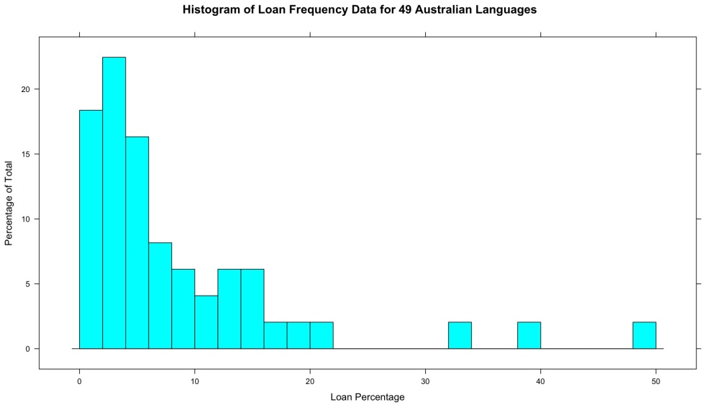
- Reconstructions for each word set using the comparative method (Bowern for Nyulnyulan, Karnic, Yardli and Marrngu; drawing also on Weber (2009); McConvell for Ngumpin-Yapa, Bunuban and Jarragan; joint work for Yolŋu.)
- Loan identification criteria include
  - Parsibility (e.g. word in language X is morphologically simple in X but parsible in Y, implies loan from Y);
  - (non) participation in regular sound changes;
  - Contains non-native phonemes;
  - Etc
- That is, we used the same criteria that others have used elsewhere in the world in analyzing loans in combination with the comparative method.
- Chose languages which have some previous historical work;
- Began with languages where the contact history is readily identifiable (e.g. along the Non-Pama-Nyungan/Pama-Nyungan border).

§7 Coding Conventions
- Inherited:: Word is inherited from an earlier stage of the language;
- Semantic shift:: Material is inherited but with a different meaning from the reconstructed one (e.g. Ngumbarl nimirdi 'ankle' < Proto-Nyulnyulan 'knee')
- Loan:: Word is a loan into the language from another language (Bardi warrgam < English 'work');
- Doubtful loan:: Word is probably/possibly a loan but for various reasons can't be established as such with certainty;
- Loan into Proto-Language:: Word is a loan into an earlier stage of the language (e.g. Nyulnyulan *warrakana 'eagle' < Pama-Nyungan 'animal'; Bardi reflex arriyana shows that the loan is old; Proto-Nyulnyulan *bukarri 'dream' is also widespread in Pama-Nyungan)
- (Loan direction unknown:: Word is a loan but the source/donor pairing can't be identified;)
- Unique:: Word is untraceable; no etymology (from available sources);
- (Unknown:: Word is currently untraceable but not all sources have been exhausted, or etymology can't be determined;)
- Missing:: No word is given in the source.
Results (For full table of results, see last page)
§8 Summary of Figures:
- Average loan rates: 8.67%
- StDev 8.9
- Median rate: 5.5%
- Minimum loans: 0% (rare; Nimanburru and Karuwali, both not very well attested)
- Maximum loans: 48% (Gurindji)
How do Australian languages compare to the rest of the world?

§9 Australian languages in the survey thus have a similar profile to other languages:
- Very few languages with no loans;
- Many languages with a few loans;
- Few languages with many loans.

§10 Most and Least loaned vocabulary:
- Least (most likely to be inherited): who, 1sg, 2pl, bite, 2sg, what, breast, hand, foot, 1pl, eye, egg, two, and, bone, 3sg, smell, nose, cry, earth
- Most loaned: count, house, work, roof, ear, ash [though overall loan numbers for this list, remember, are small]
- Least reconstructible (most single-attestation items): come, grindstone, winnow, thunder, how, if, neck, thin, turn, dirty, rain, lie down, hide, throw, root, tree, fear, itch

Loan sources
§11 How many languages contribute to borrowing?
- Gurindji has more than 20 sources, but does not itself contribute many loans to languages in the region.
- High 'donor' languages:
  - Arabana (many words into Diyari and Malyangapa)
  - English (few words into many languages)
  - Makassar (into Yolŋu languages, particularly in non-basic vocabulary)
  - Burarra (into Yan-nhaŋu)

§12 The data show cases of both symmetric and asymmetric borrowing:
- Symmetric:
  - Yawuru and Karajarri (10-15%);
- Asymmetric:
  - Malyangapa and Karnic languages;
  - Gurindji and surrounding languages;
  - Borrowing chains: Arandic > Arabana > Diyari > Malyangapa (but with different words)
- Less symmetric than we thought:
  - Ngandi, Wubuy (Nunggubuyu) and Ritharrŋu
    - Loan levels are higher in Ritharrŋu (22%) than in the other two (15% and 5% respectively for this list)
- Areas of high areal 'sharing' (where loan direction is indeterminate)
  - Karnic
  - Paakantyi and Malyangapa

§13 Loans from English?
- 'work' (in 6 languages)
- 'road' (in 2 langs)
- 9 other words (rope, dog, new, white, etc)
- some with semantic shift:
  - Yan-nhaŋu biriyanaraŋu 'white' < 'prayer'
  - Djinaŋ botji 'dog' < 'pussy (cat)'

'Causes' of high loan levels?
§14 See Bowern et al (submitted) for analysis of basic demographic factors such as population size, density, and mobility.
- None of these factors correlated with loan levels in that data set.
- Nor do multilingualism or linguistic exogamy.
- However, a few social situations very particularly associated with high levels of borrowing:
  - Migration accompanied by language shift into the language (Gurindji into the Victoria River District; see McConvell 2009)
  - Language shift away from the language (Bankalachi-Toloim in California; perhaps Malyangapa in this survey).
- Furthermore, not all high contact situations (as defined by participation in trade networks, etc) lead to high loan levels.

Conclusions
§15 This study shows that loan rates in Australian languages (at least the ones surveyed here) are for the most part considerably lower than have been assumed, and do not irretrievably cloud Australian reconstructible linguistic history.
- Rates for most of the country are well under that which interferes with subgrouping (Greenhill, Currie, & Gray 2009);
- Data show variable language contact situations, both symmetric and asymmetric, high and low, and in between.
- Therefore the picture of loans in Australia is considerably more nuanced (and interesting!) than previously thought.

References
Alpher, Barry & David Nash. 1999. Lexical replacement and cognate equilibrium in Australia. Australian Journal of Linguistics 19(1). 5-56.
Bowern, Claire. 2009. Reassessing Karnic: a reply to Breen (2007). Australian Journal of Linguistics 29(3).
Breen, Gavan. 2007. Reassessing Karnic. Australian Journal of Linguistics 27(2). 175–199.
Clendon, Mark. 2006. Reassessing Australia's linguistic prehistory. Current Anthropology 47(1). 39-61.
Dench, Alan. 1998. Pidgin Ngarluma: an indigenous contact language in north western Australia. Journal of Pidgin and Creole languages 13(1). 1–61.
Dench, Alan. 2001. Descent and diffusion: The complexity of the Pilbara situation. In Alexandra Y. Aikhenvald & R. M. W. Dixon (eds.), Areal diffusion and genetic inheritance: Problems in comparative linguistics, 105–133. Oxford / New York: Oxford University Press.
Dixon, R. M. W. 1997. The rise and fall of languages. Cambridge, UK / New York: Cambridge University Press.
Dixon, R. M. W. 2002. Australian languages: Their nature and development. (Cambridge Language Surveys). Cambridge, UK / New York: Cambridge University Press.
Gray, R. D., S. Greenhill & R. Blust. 2007. Computational phylogenetic methods and Austronesian subgrouping. In , International Congress of Historical Linguists, Montreal.
Greenhill, S. J., T. E. Currie & R. D. Gray. 2009. Does horizontal transmission invalidate cultural phylogenies? Proceedings of the Royal Society B: Biological Sciences 276(1665). 2299-2306. doi:10.1098/rspb.2008.1944.
Haspelmath, M. 2004. How hopeless is genealogical linguistics, and how advanced is areal linguistics? Studies in Language 28(1). 209-223.
Haspelmath, M. & U. Tadmor. 2009. Loanwords in the World's Languages: A comparative handbook. Berlin: Mouton de Gruyter.
Heath, Jeffrey. 1978. Linguistic diffusion in Arnhem land. (Australian Aboriginal Studies - Research and Regional Studies 13). Australian Institute of Aboriginal Studies.
Heath, Jeffrey. 1981. A case of intensive lexical diffusion: Arnhem Land, Australia. Language 57(2). 335-367.
Hercus, Luise. 1987. Linguistic diffusion in the Birdsville area. In Donald C. Laycock & Werner Winter (eds.), A world of language: Papers presented to Professor S. A. Wurm on his 65th birthday, 245-255. (Pacific Linguistics C-100). Canberra: Dept. of Linguistics, Research School of Pacific Studies, Australian National University.
Hercus, Luise. 1994. A grammar of the Arabana-Wangkangurru language, Lake Eyre Basin, South Australia. (Pacific Linguistics C-128). Canberra: Pacific Linguistics.
Johnson, S. 1990. Social parameters of linguistic change in an unstratified Aboriginal society. In Philip Baldi (ed.), Linguistic change and reconstruction methodology, 419-33. Berlin: Mouton de Gruyter.
McConvell, Patrick. 1988. Mix-im-up: Aboriginal code-switching, old and new. In M. Heller (ed.), Codeswitching: anthropological and sociolinguistic perspectives, 97-124. Berlin: Mouton de Gruyter.
McConvell, Patrick. 2001. Mix-im-up speech and emergent mixed languages in indigenous Australia. Texas Linguistics Forum 44(2). 328-349.
McConvell, Patrick. 2007. Mixed languages as outcomes of code-switching; recent examples from Australia and their implications. Language Contact and the Dynamics of Language. 187.
McConvell, Patrick. 2009. Loanwords in Gurindji. In Martin Haspelmath & Uri Tadmor (eds.), Loanwords in the World's Languages: A comparative handbook, 790-822. the Hague: Mouton.
McConvell, Patrick. 2010. Contact and Indigenous Languages in Australia. In , Handbook of Language Contact. Oxford: Blackwell Wiley.
McConvell, Patrick & F. Meakins. 2005. Gurindji Kriol: a mixed language emerges from code-switching. Australian Journal of Linguistics 25(1). 9-30.
Weber, Natalie. 2009. Reconstruction of Proto-Marrngu. Houston: Rice University ba honors thesis.

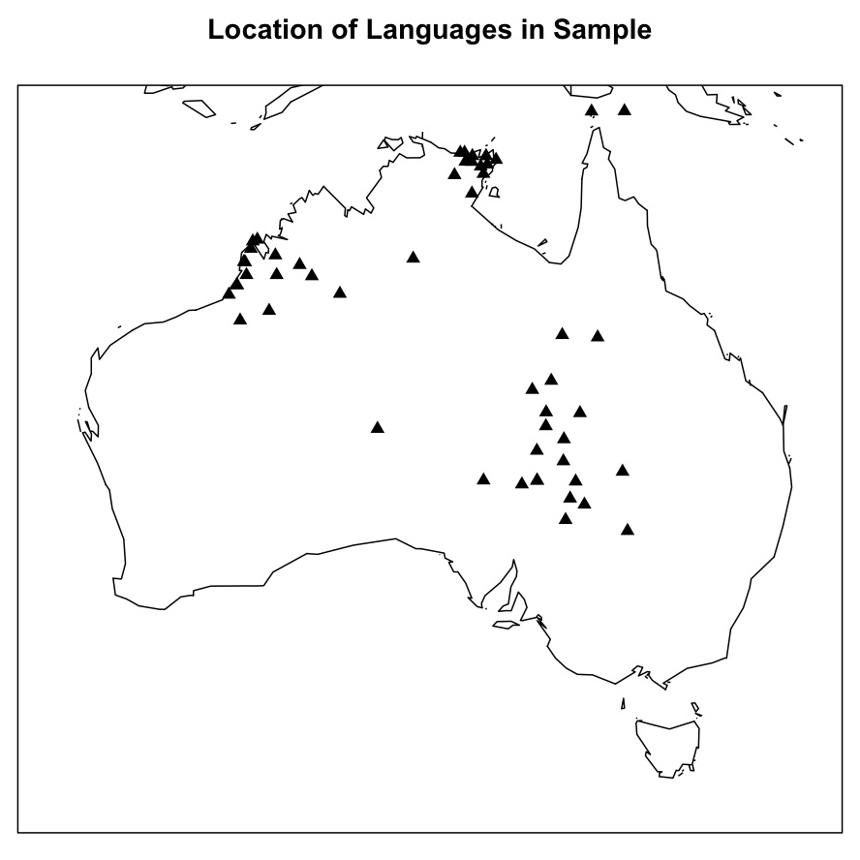
Summary Data: Loans in a Sample of Australian Languages
Family | Subgroup | Language | Loan | Doubtful | Missing | Inherited | Unique | Loan %age
Nyulnyulan | Western | Bardi | 4 | 1 | 2 | 173 | 17 | 1.98
 |  | Nyulnyul | 2 | 0 | 20 | 169 | 10 | 1.09
 |  | Nimanburru | 0 | 0 | 48 | 144 | 11 | 0.00
 | Eastern | Ngumbarl | 2 | 2 | 37 | 124 | 36 | 1.20
 |  | Yawuru | 19 | 1 | 13 | 133 | 32 | 9.95
 |  | Nyikina | 11 | 1 | 23 | 136 | 27 | 6.08
 |  | Warrwa | 3 | 0 | 60 | 112 | 22 | 2.08
Bunuban |  | Bunuba | 17 | 14 | 23 | 52 | 98 | 9.39
 |  | Gooniyandi | 56 | 15 | 39 | 56 | 32 | 33.94
Jarragan |  | Gajirrabeng | 14 |  | 14 | 97 | 79 | 7.37
 |  | Miriwoong | 16 |  | 24 | 101 | 63 | 8.89
 |  | Kija | 27 |  | 11 | 100 | 66 | 13.99
Maningrida |  | Burarra | 22 | 7 | 20 | 6 | 138 | 11.96
Gunwinyguan |  | Rembarrnga | 7 | 1 | 0 |  |  | 3.43
 |  | Ngandi | 25 |  | 32 | 53 | 58 | 14.53
 |  | Nunggubuyu | 11 | 2 | 7 | 59 | 63 | 5.58
Pama- | Marrngu | Mangala | 23 | 10 | 11 | 75 | 82 | 11.92
Nyungan |  | Northern Mangarla | 23 | 6 | 59 | 37 | 26 | 15.86
 |  | Northern Nyangumarta | 10 | 3 | 22 | 127 | 37 | 5.49
 |  | Nyangumarta | 13 | 4 | 10 | 111 | 44 | 6.70
 |  | Karajarri | 29 | 6 | 14 | 116 | 35 | 15.26
 | Ngumpin- | Walmajarri | 26 | 6 | 3 | 155 | 14 | 12.94
 | Yapa | Mudburra | 75 | 7 | 8 | 67 | 47 | 38.27
 |  | Gurindji | 98 | 0 | 1 | 85 | 19 | 48.28
 |  | Jaru | 31 | 6 | 13 | 125 | 29 | 16.23
 | Yolngu | Djapu | 4 | 1 | 55 | 61 | 68 | 2.68
 |  | Djinang | 7 | 2 | 7 | 61 | 123 | 3.55
 |  | Dhangu | 6 | 3 | 30 | 82 | 76 | 3.45
 |  | Gupapuyngu | 5 |  | 29 | 70 | 95 | 2.86
 |  | Yan-nhangu | 10 | 2 | 27 | 80 | 72 | 5.65
 |  | Ritharrngu | 42 | 0 | 13 | 104 | 37 | 21.99
 | Karnic | Yandruwandha | 3 | 1 | 6 | 123 | 62 | 1.52
 |  | Mount Freeling Diyari | 2 | 0 | 75 | 71 | 51 | 1.55
 |  | Arabana | 9 | 9 | 11 | 81 | 79 | 4.66
 |  | Diyari | 8 | 2 | 7 | 135 | 39 | 4.06
 |  | Pitta-Pitta | 3 | 1 | 31 | 91 | 69 | 1.73
 |  | Wangkayutyuru | 6 | 1 | 36 | 71 | 82 | 3.57
 |  | DiyariREU | 22 | 0 | 82 | 64 | 25 | 18.03
 |  | Mithaka | 3 | 1 | 75 | 87 | 30 | 2.33
 |  | Karuwali | 0 | 3 | 135 | 34 | 30 | 0.00
 |  | Ngamini | 4 | 6 | 7 | 127 | 50 | 2.03
 |  | Yarluyandi | 2 | 1 | 66 | 92 | 34 | 1.45
 |  | Yawarrawarrka | 5 | 2 | 24 | 107 | 54 | 2.78
 |  | Nhirrpi | 6 | 0 | 74 | 80 | 39 | 4.62
 |  | Guwa | 4 | 0 | 122 | 43 | 30 | 4.88
 |  | Yanda | 4 | 1 | 133 | 33 | 29 | 5.63
 | Yardli | Malyangapa | 18 | 7 | 65 | 40 | 46 | 12.95
 |  | Wadikali | 1 | 1 | 178 | 18 | 4 | 3.85
 |  | Yardliyawarra | 2 | 1 | 173 | 23 | 3 | 6.45

Note that these figures are lower than those reported in Bowern et al (submitted), which contained fewer Australian languages.
This is skewed by the Yolŋu languages in the sample, many of which have bothulu for ‘ear’ (from English ‘bottle’).

